Northwestern State University is located in beautiful, historic Natchitoches, Louisiana, the oldest (1714) settlement in the Louisiana Purchase. NSU was founded in 1884 as Louisiana Normal School for the education of teachers. In 1921 the school’s name was changed to Louisiana State Normal College, then designated as Northwestern State College of Louisiana in 1944. Its current title, an indication of NSU’s diversity of programs and services, became official in 1970.



Northwestern’s School of Creative and Performing Arts, designated as an “Area of Excellence” by the University of Louisiana Board of Trustees and generously endowed by the H.D. Dear family of Alexandria, Louisiana, is comprised of three areas: Music, the Fine and Graphic Arts, and Theatre. All three disciplines confer undergraduate degrees, and Music and the Fine and Graphic Arts also offer graduate degrees. To learn more about the School of Creative and Performing Arts, please contact:

Dr. Greg Handel, Director (318) 357-4522 handelg@nsula.edu
Dr. Malena McLaren, Music Coordinator (318) 357-5758 mclarenm@nsula.edu
Mr. Scott Burrell, Theatre Coordinator (318) 357-6891 nfburrellc@nsula.edu
Mr. Matt DeFord, Art Coordinator (318) 357-6560 defordm@nsula.edu

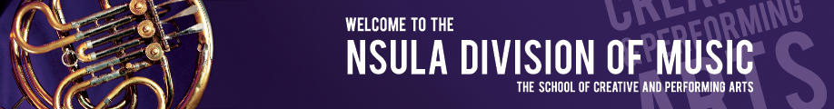

NSU music students rehearse, attend classes, take private instruction, and perform in one of the most outstanding Performing Arts facilities in the South, the A.A. Fredericks Center for the Creative and Performing Arts, named to honor one of Northwestern’s most outstanding administrators.

The Magale Recital Hall, endowed by the Magale family of Waterproof, Louisiana, seats over 400, and is one of the finest concert halls in the U.S. It is equipped with a 40-rank Reuter organ, two nine-foot grand pianos, and an Eric Hertz harpsichord. The 1400-seat Fine Arts Auditorium is used for larger concerts, musicals and opera, dance, and numerous theatre productions.

Many performing opportunities for students include several choirs, opera theatre, orchestra, marching band, wind ensemble, jazz orchestra, percussion ensemble, and a variety of chamber music groups. Degree offerings include the Bachelor of Music in Performance, the Bachelor of Music/Sacred Music Concentration, the Bachelor of Music Education, and the Master of Music.

Students are eligible to receive scholarships for participation in music ensembles, regardless of their academic major. Scholarship awards vary, and are determined by factors including a talent audition, high school achievements, academic scores and financial need. For further information, please contact CAPA Director, Dr. Greg Handel at handelg@nsula.edu.

Mrs. H.D. Dear, Sr. and Alice E. Dear
School of Creative and Performing Arts

Natchitoches, Louisiana

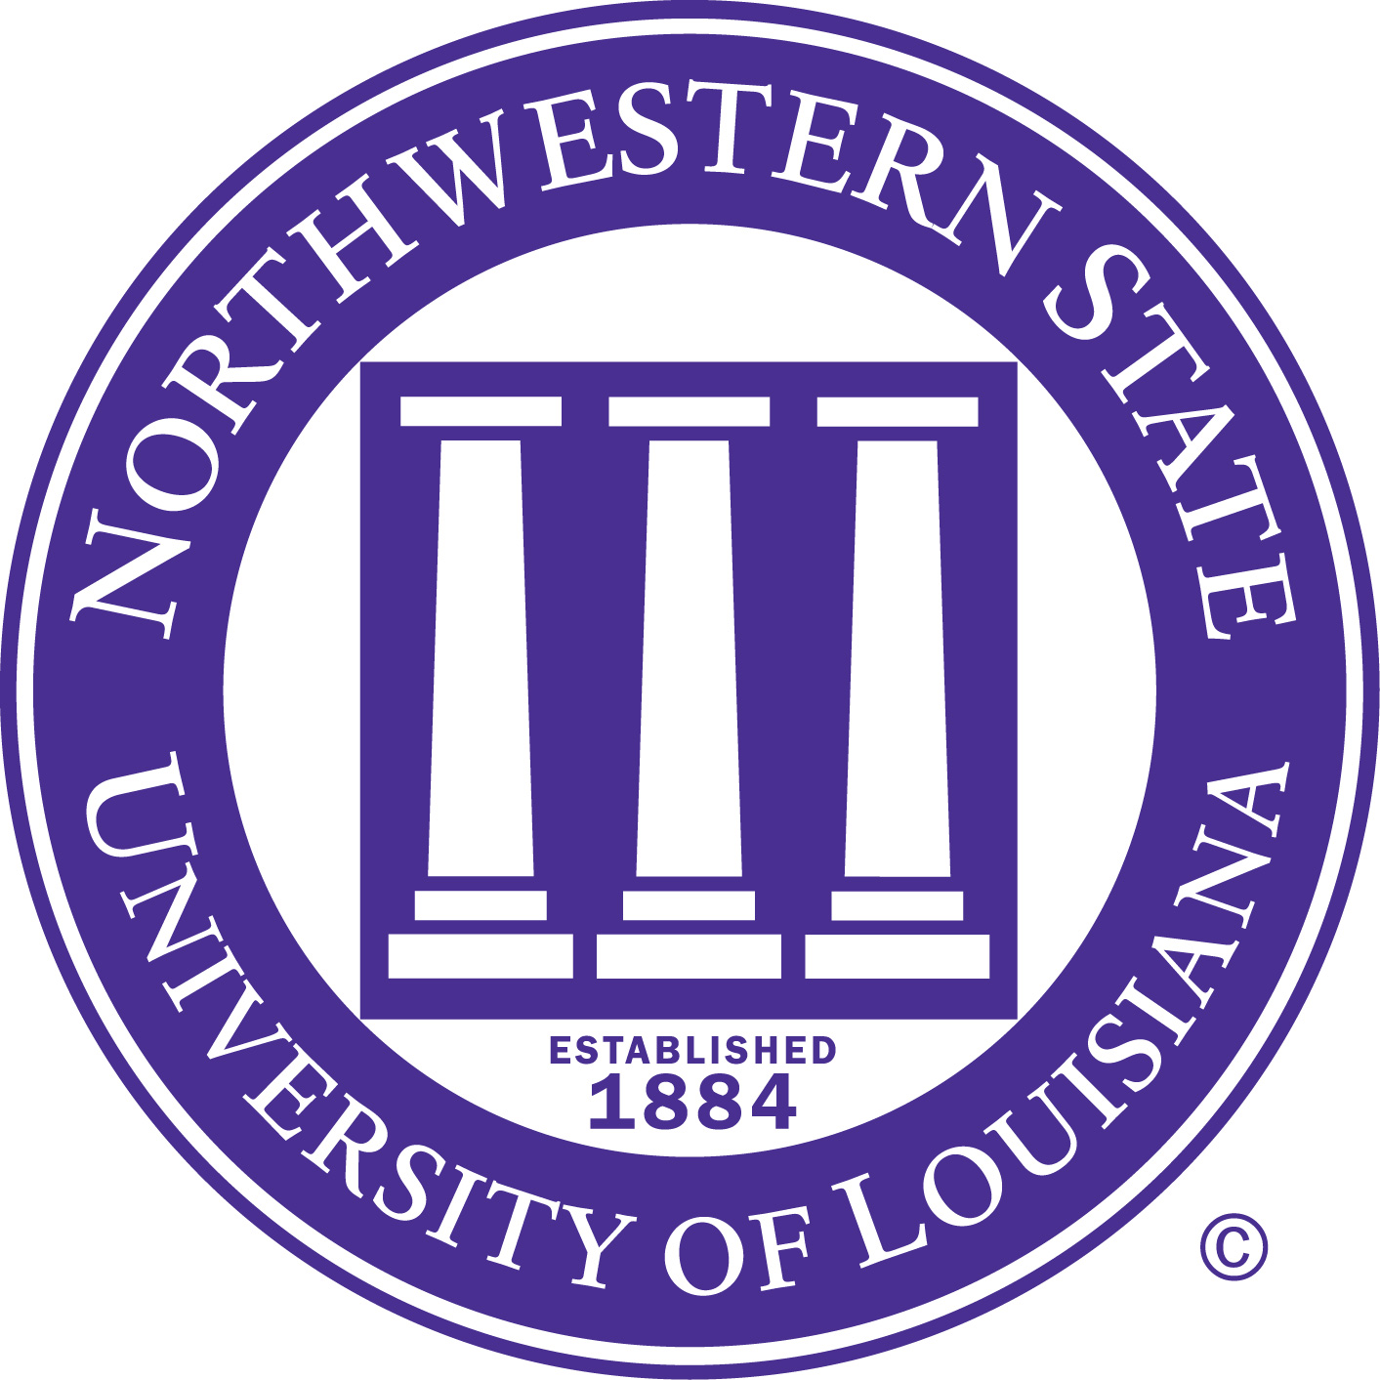

Presents

Tuesday, July 30, 2013
Magale Recital Hal
7:30 p.m.

Presents

Friday, May 10, 2013
Magale Recital Hall
11:00 a.m.

˜ Program ™

String Quartet in C major, K. 157 Wolfgang Amadeus Mozart
(1756-1791)
I. Allegro
II. Andante
III. Presto

String Quartet #1 in D major, Opus 11 Peter Ilyitch Tchaikovsky
(1840-1893)
Moderato e semplice-Allegro non troppo ma con fuoco
Andante cantabile
Scherzo: Allegro non tanto e con fuoco
Finale: Allegro giusto-Andante-Allegro vivace

PLAY WITH US! MUSIC SCHOLARSHIPS @ NORTHWESTERN STATE


Program

